11.conference management system

Use case digram

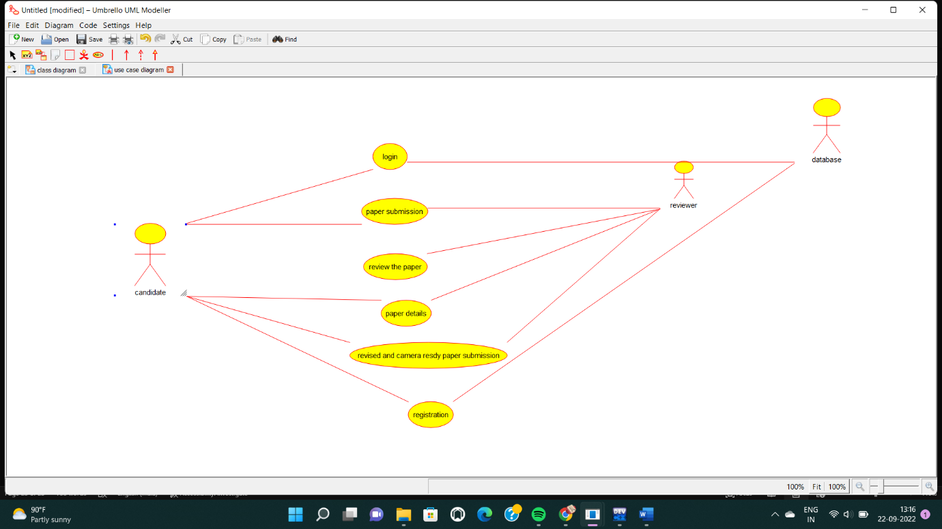

Class diagram

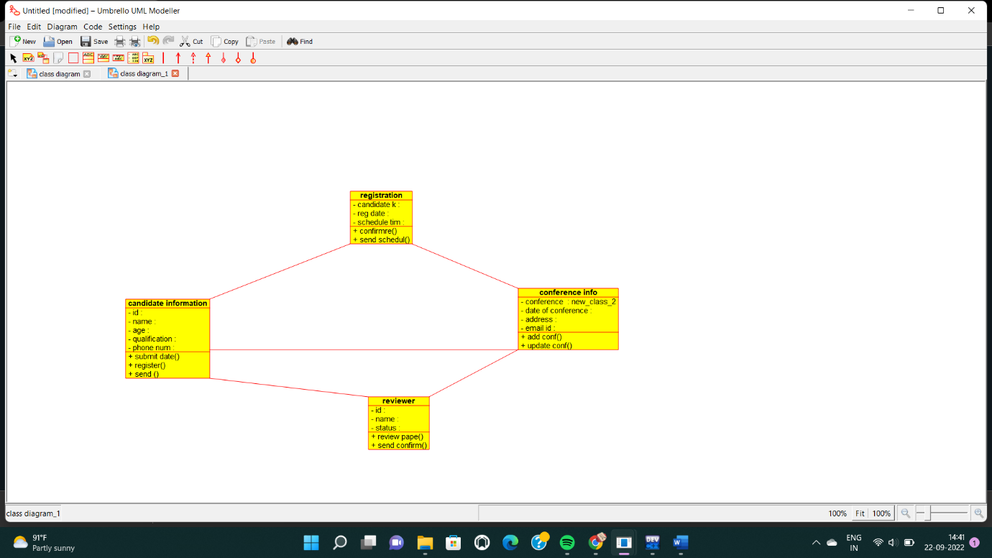

Source code

include "candidate_information.h"

// Constructors/Destructors

//

candidate_information::candidate_information () {

initAttributes();

}

candidate_information::~candidate_information () { }

//

// Methods

//

// Accessor methods

//

// Other methods

//

void candidate_information::initAttributes () {

}